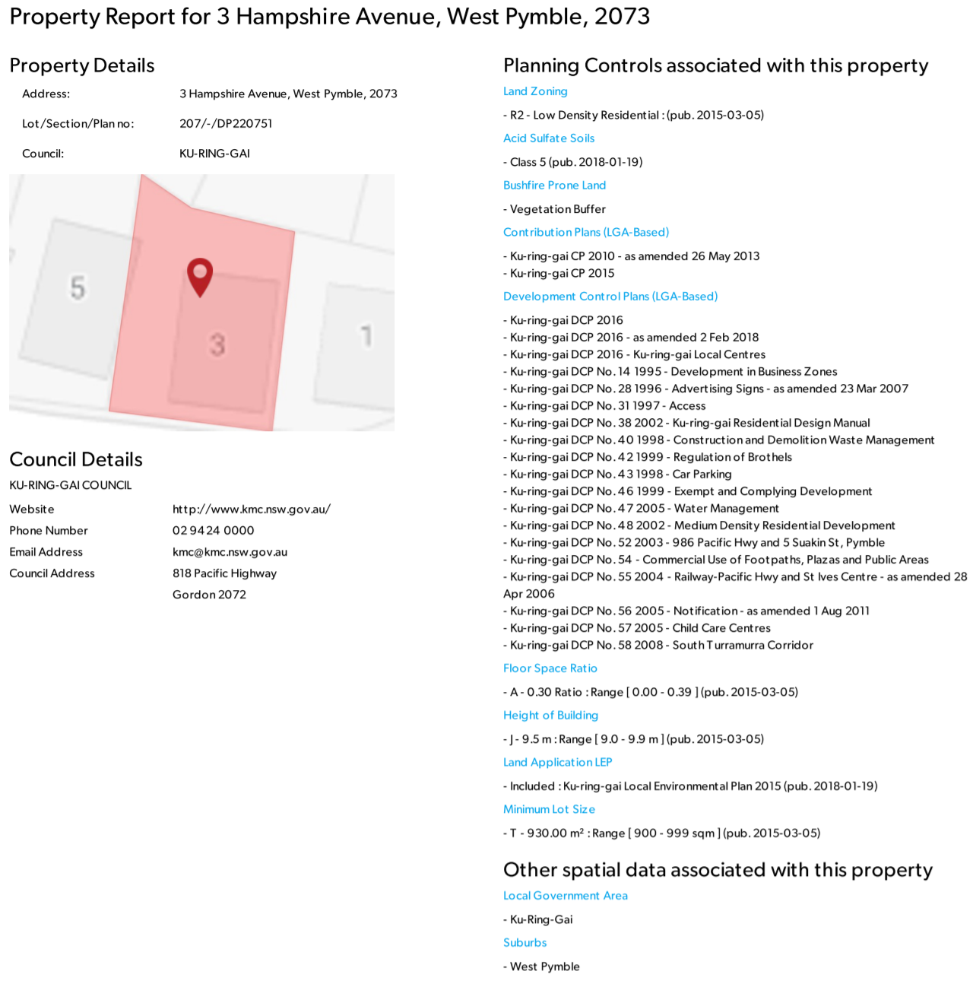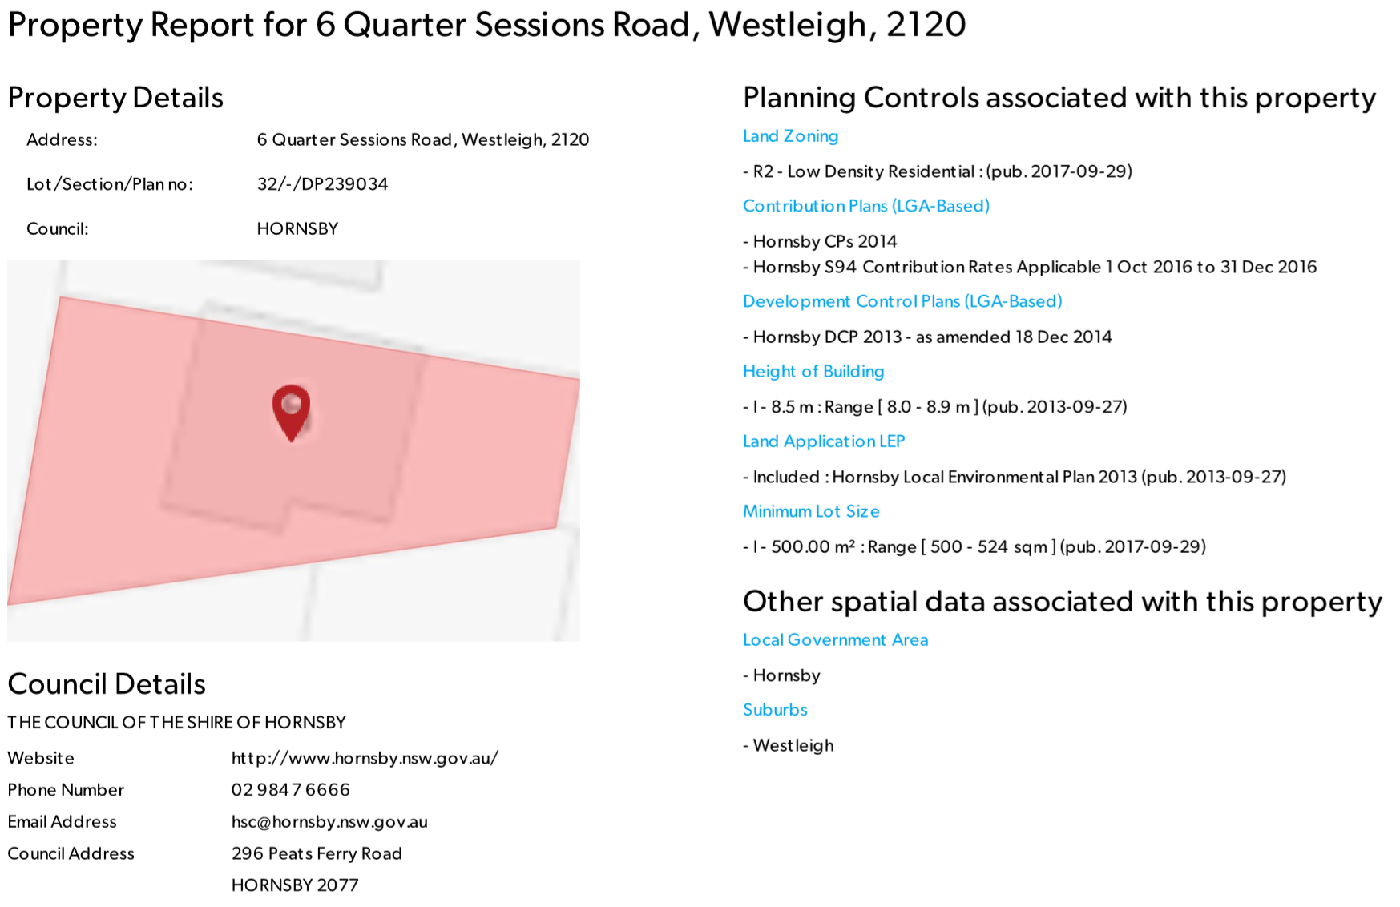

<https://www.planningportal.nsw.gov.au/find-a-property/697355_3_Hampshire_Avenue_207_West_Pymble_DP220751>

https://www.stepps.com.au/company-category/data/ **EXCELLENT SIte**